|  |  |  |
| --- | --- | --- |
| Taylor Sloan | CSCI 251, Bob Robertson | MWF 2:00-3:30 |
|  |  |  |

1. 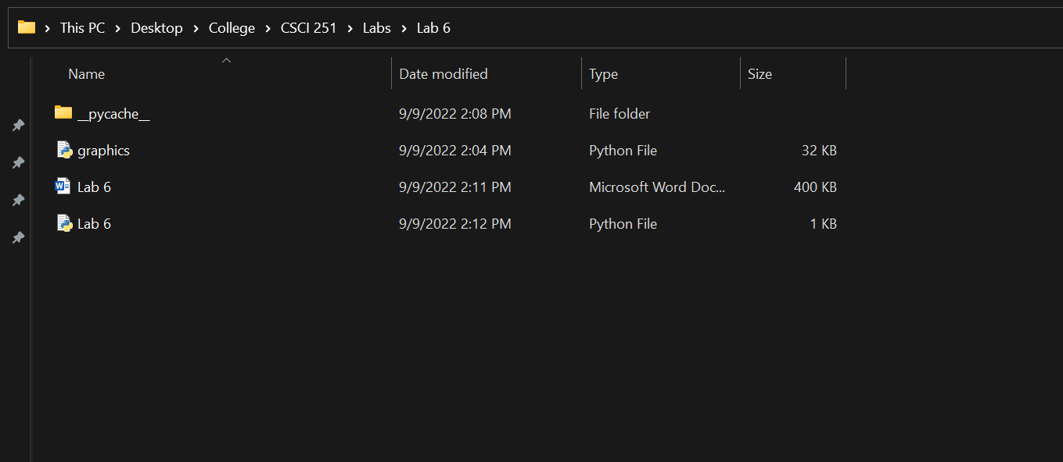
2. Graphical user interface

   Description automatically generated with low confidence
3. Instance of a GraphWin object
4. Graphical user interface, application, Word

   Description automatically generated
5. Multi Part
   1. Graphical user interface, application, Word

      Description automatically generated
   2. Graphical user interface, application

      Description automatically generated
   3. Graphical user interface, application, Word

      Description automatically generated
6. Multi Part
   1. Graphical user interface, application

      Description automatically generated
   2. Graphical user interface, application, Word

      Description automatically generated